Wireframe Document

Heart Disease Diagnostic Analysis



# Revision Number - 1.2

**Last Date of Revision - 01/04/2023**

# RAHUL

**Document Control**

|  |  |  |  |
| --- | --- | --- | --- |
| **Date** | **Version** | **Description** | **Author** |
| 01/08/2022 | 1.0 | Introduction, Problem Statement | Rahul |
| 21/10/2022 | 1.1 | Dataset Information, Architecture Description | Rahul |
| 01/04/2023 | 1.2 | Final Revision | Rahul |
|  |  |  |  |

# We Performed Exploratory Data Analysis on Jupyter Notebook and then created a Power BI Desktop Dashboard.

## What Kind of Population do we have?

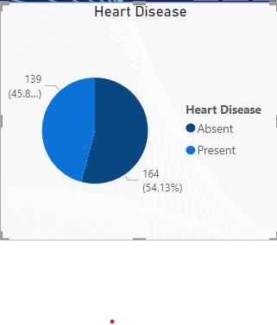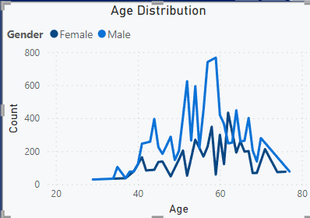

* 45.87% People suffering from heart disease.
* Elderly Aged Men are more (50 to 60 Years) and Females are more in 55 to 65 Years Category

## Who Suffer from Heart Disease?

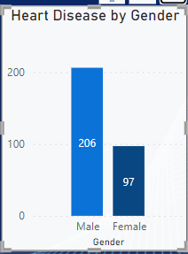

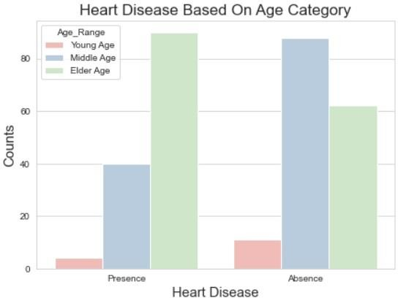

* Males are more prone to heart disease.
* Elderly Aged People are more prone to heart disease.

## What symptoms people experience in heart disease

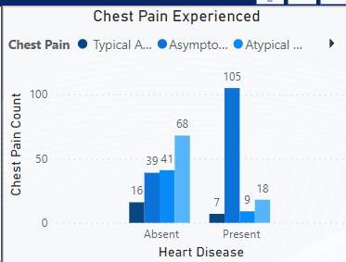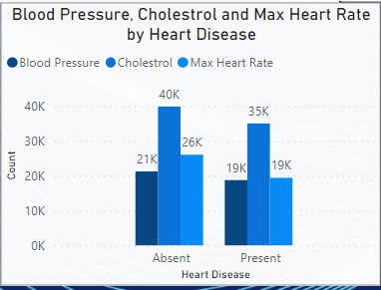

* It seems people having asymptomatic chest pain have a higher chance of heart disease.
* Asymptomatic Chest pain means neither causing nor exhibiting symptoms of heart disease.
* It seems high number of cholesterol level in people having heart disease.

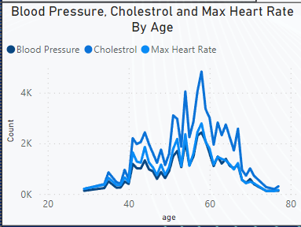

* Here we can observe that Blood Pressure increases between age of 50 to 60 and somehow continue the pattern till 70.
* Similarly, Cholesterol and maximum heart rate Increasing in the age group of 50-60.

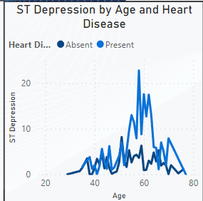

* we can observe from here that ST depression mostly increases between the age group of 30-40.
* ST depression refers to a finding on an electrocardiogram, wherein the trace in the ST segment is abnormally low below the baseline.